myRMIT Enrolments Video Accessible Version

Slide 1: Welcome to myRMIT enrolments
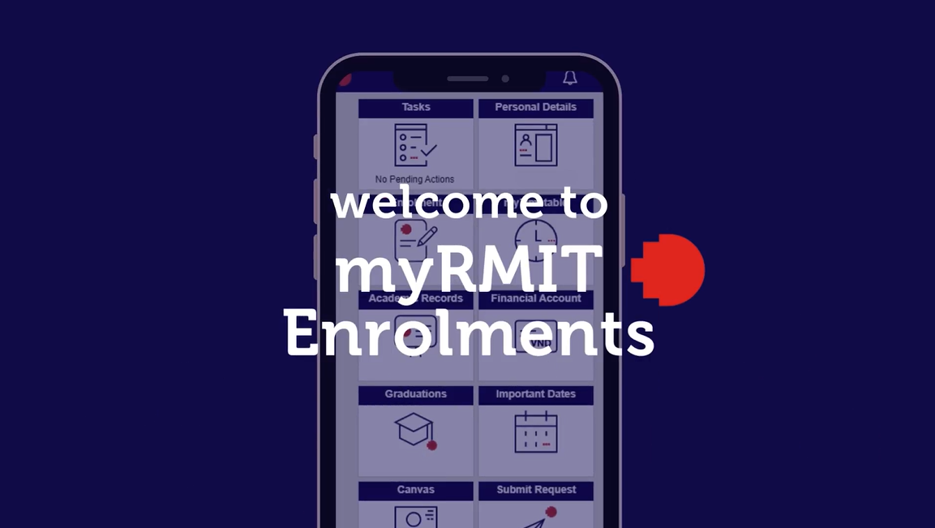

Slide 2: Today’s Topics
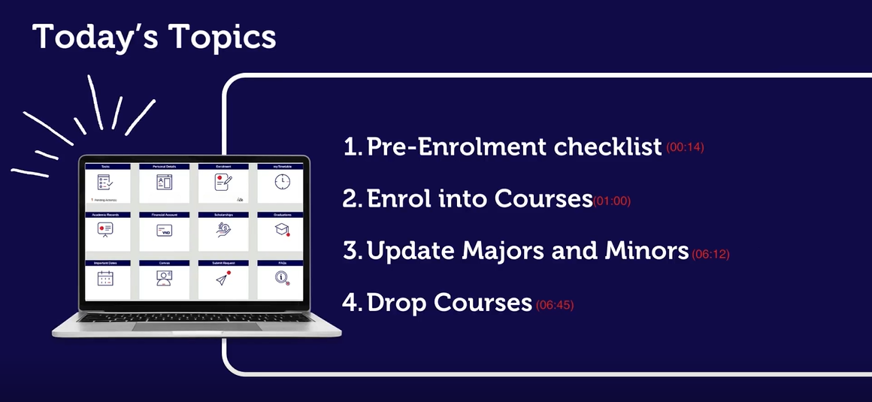
Today’s Topics:
- Pre-Enrolment Checklist
- Enrol into Courses
- Update Majors and Minors
- Drop Courses
RMIT university students can use the myRMIT self service system to complete all enrolment related activities.

Slide 3: Topic 1 – Pre-Enrolment Checklist
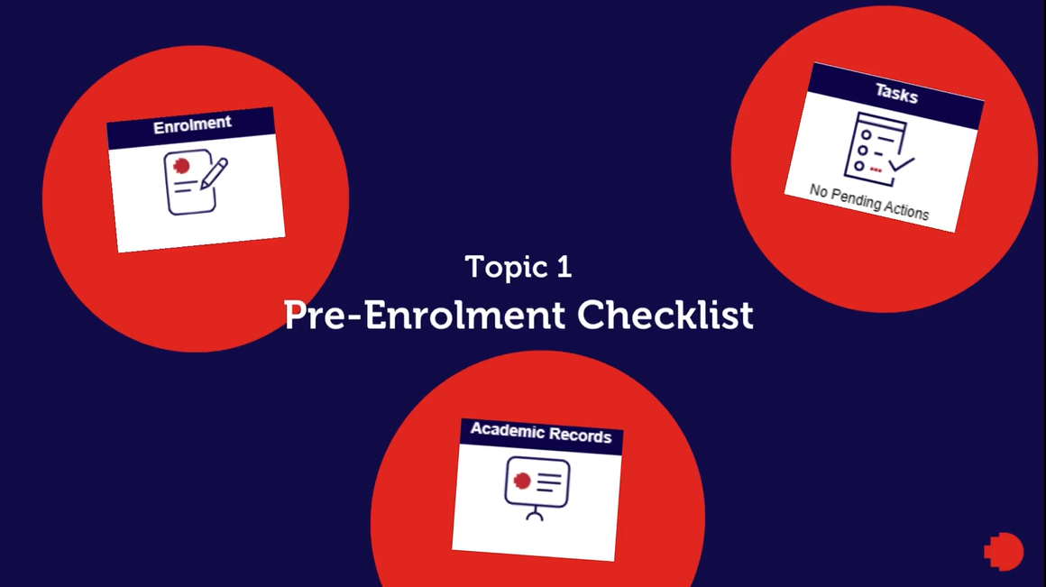

Slide 4: myRMIT login screen
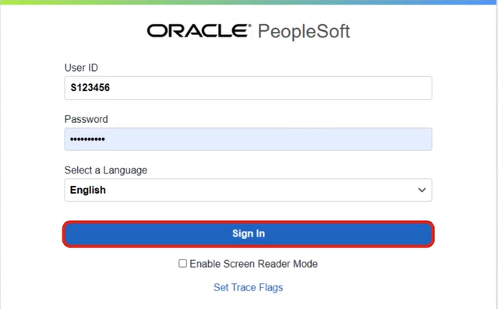
Log into myRMIT by entering your Student number in the User ID field, and your Password in the Password field. Select a Language is set to English and cannot be changed. Check the Enable Screen Reader Mode checkbox at the bottom of the screen to enable the screen reader. Click the Sign In button below the Select a Language field to log in.

Slide 5: myRMIT Home Page
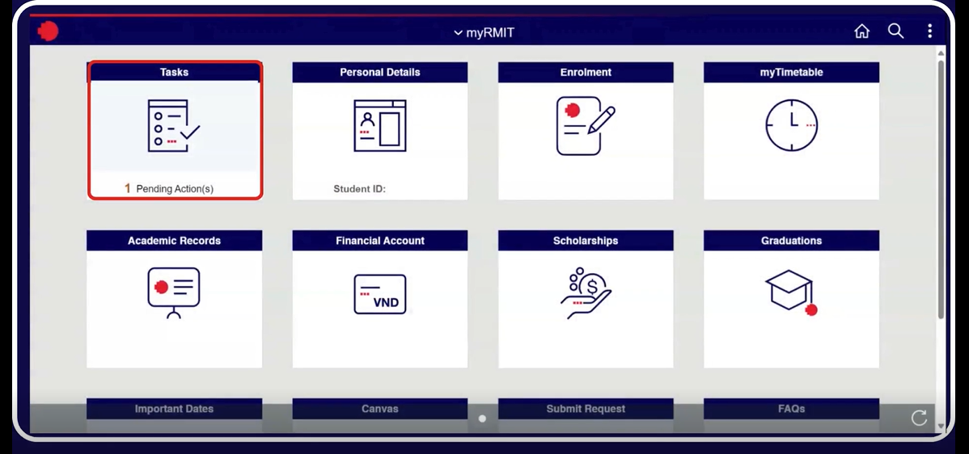
The Task tile is the top left tile. The Task tile shows 1 Pending Action if the Pre-Enrolment checklist has not been completed.
All students must enrol for the entire academic year. Before enrolling, you must complete the Pre-Enrolment Checklist available in the Task tile.
Click on the Task tile to complete the action.

Slide 6: Tasks list
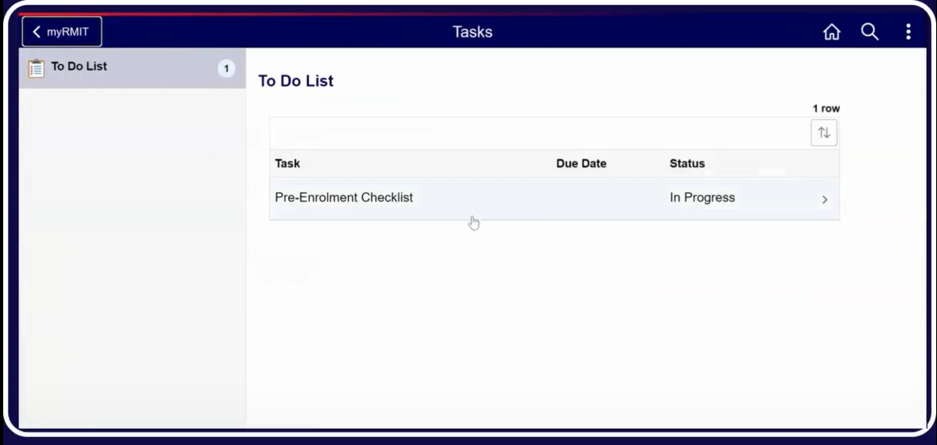
The To Do list displays, with columns Task, Due Date and Status. Pre-Enrolment Checklist is on the list. Click on the Pre-Enrolment Checklist row to start the task.

Slide 7: Pre-Enrolment Checklist, Step 1 of 9: Introduction
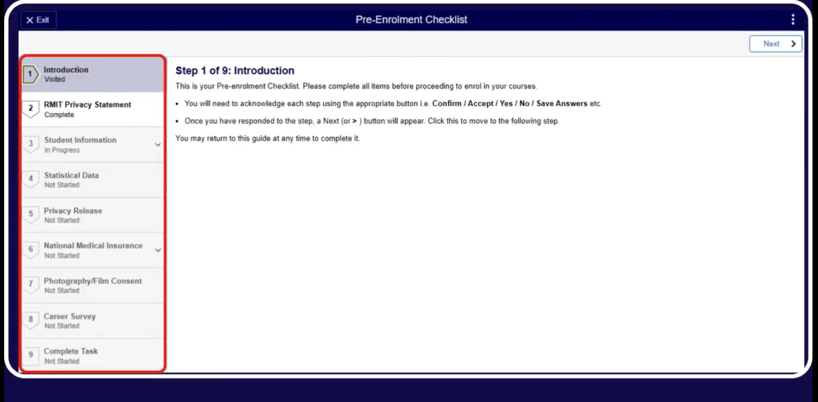
You must complete all nine steps of the Pre-Enrolment Checklist before you can enrol.
Click the Next button in the top right of the screen to continue.

Slide 8: Pre-Enrolment Checklist, Step 3 of 9: Student Information – Addresses
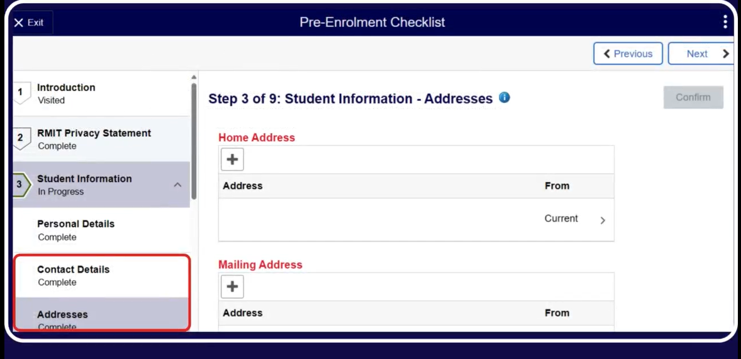
You will be asked to confirm details such as your contact and address information. Please make sure these are correct and then click the Confirm button below the Next button to confirm, then click the Next button in the top right of the screen to move to the next step.

Slide 9: Pre-Enrolment Checklist, Step 9 of 9: Complete Task
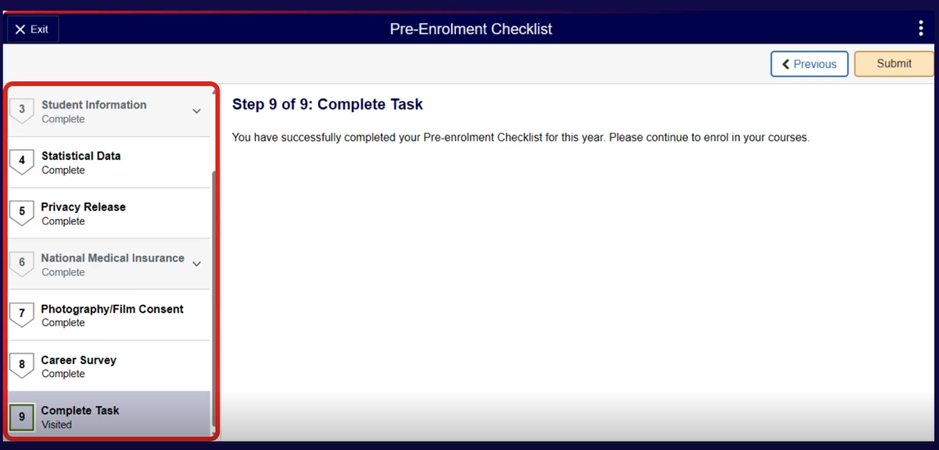
Once you have completed all nine steps, click the Submit button in the top right of the screen. You can now begin enrolling into your courses.

Slide 10: Topic 2 - Enrol into Courses
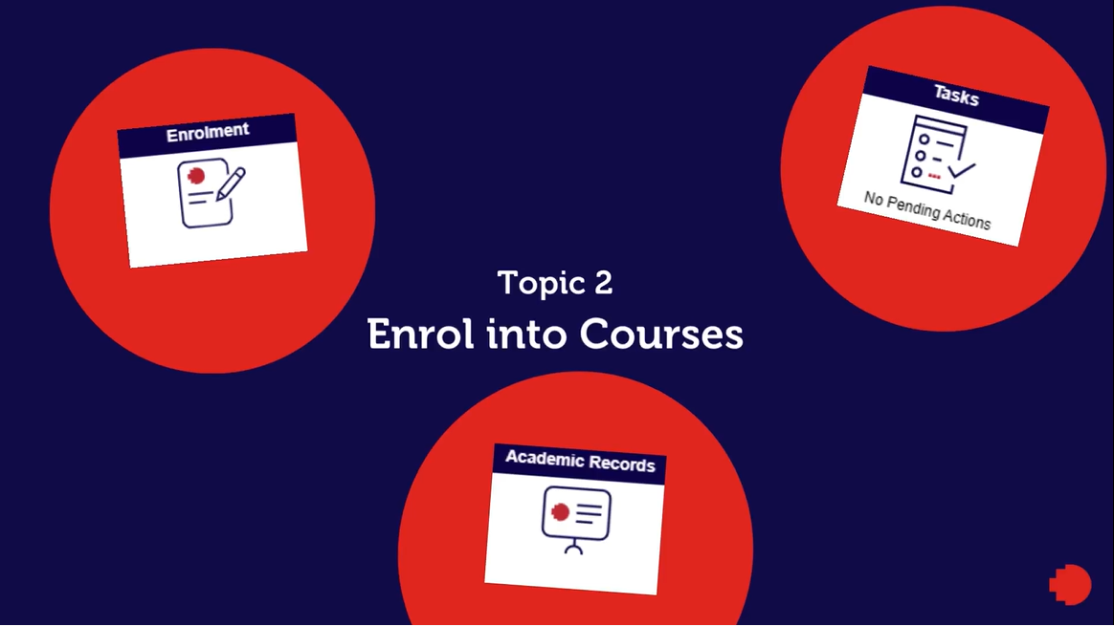

Slide 11: myRMIT Home Page
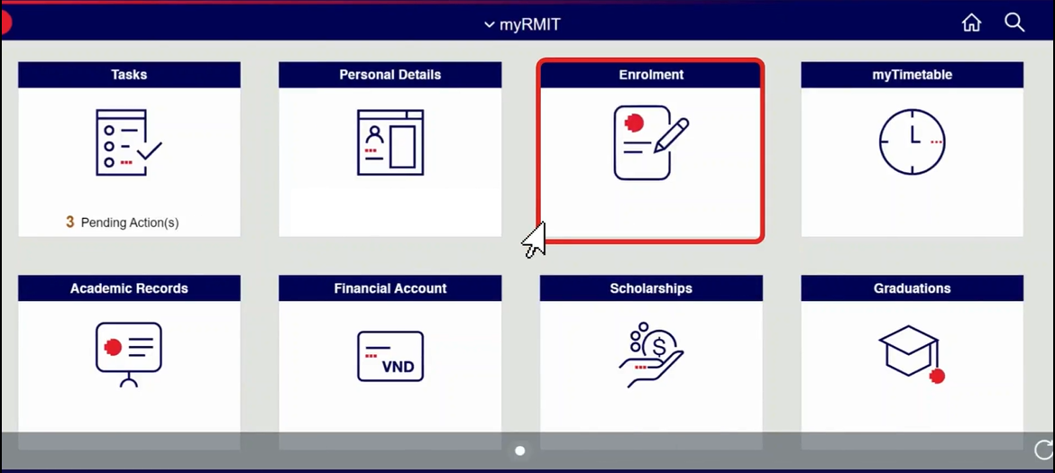
Once you have completed your Pre-Enrolment checklist, you can go to the Enrolment section from your myRMIT homepage. Click the Enrolment tile.

Slide 12: Enrol in my Program page
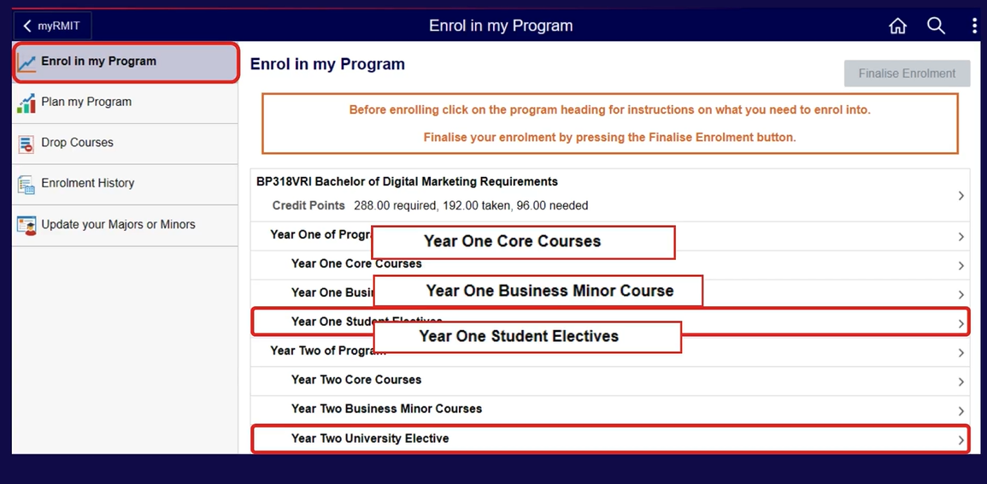
The Enrol in My Program page allows you to enrol into all your Program requirements, including core courses, courses of majors and minors and any electives.

Slide 13: Enrol in my Program page (Program heading)
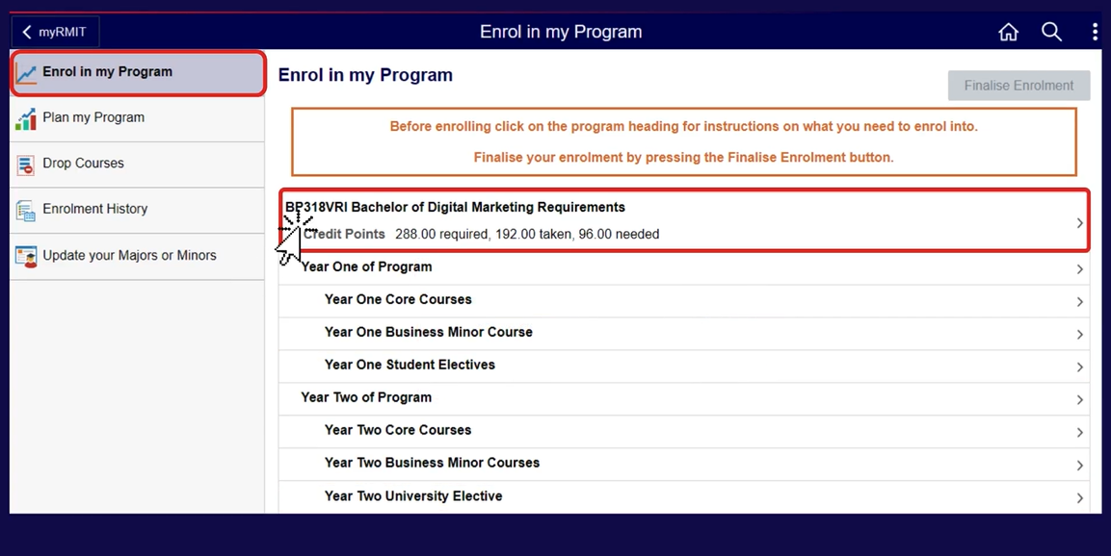
To view your detailed Program information click the Program heading.

Slide 14: Requirements Details
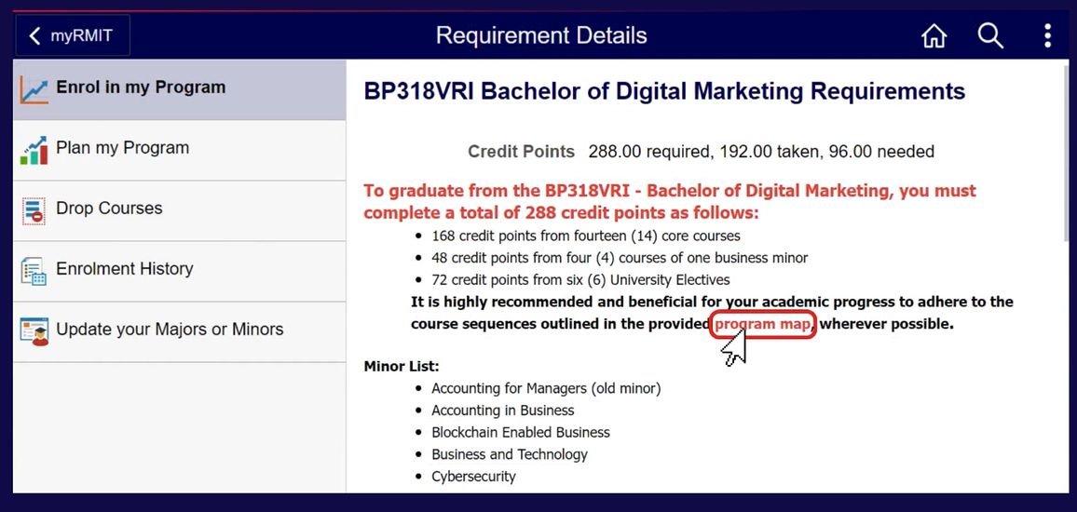
Read the information provided here carefully. Information includes total Credit Points required, Credit points already taken and credit points still required. Click the program map hyperlink to view the sequence of the core, major, minor, and option courses, as well as university electives that you need to follow for your enrolment.

Slide 15: Program Map
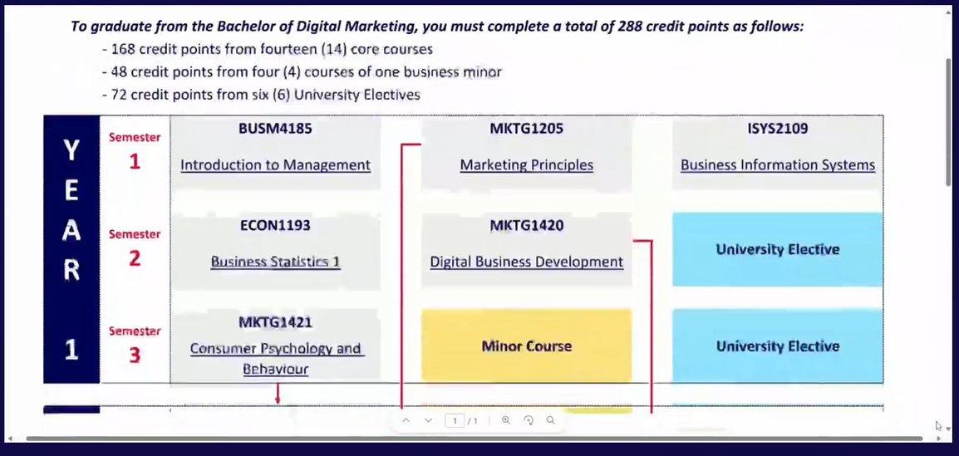
The Program Map shows the sequence of the core, major, minor, and option courses for every year of the program, as well as university electives that you need to follow for your enrolment.
Keep the Program Map page open while completing your enrolment.

Slide 16: Requirement Details – select Enrol in my Program
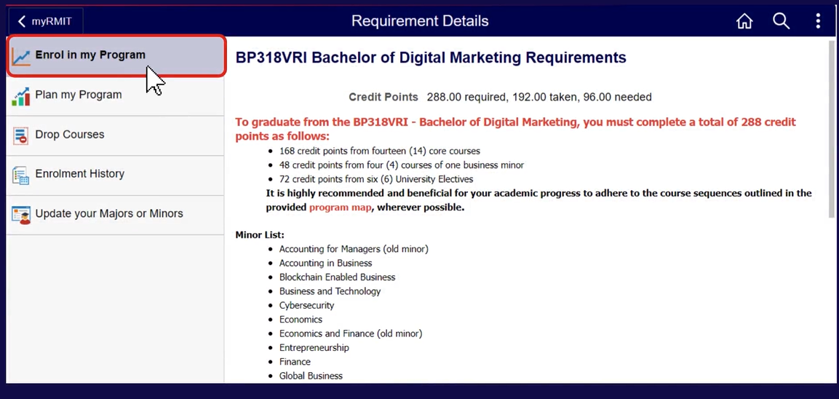
When you are ready to enrol in your courses, return to the myRMIT tab and click the Enrol in My Program tab in the left-hand menu.

Slide 17: Enrol in my Program
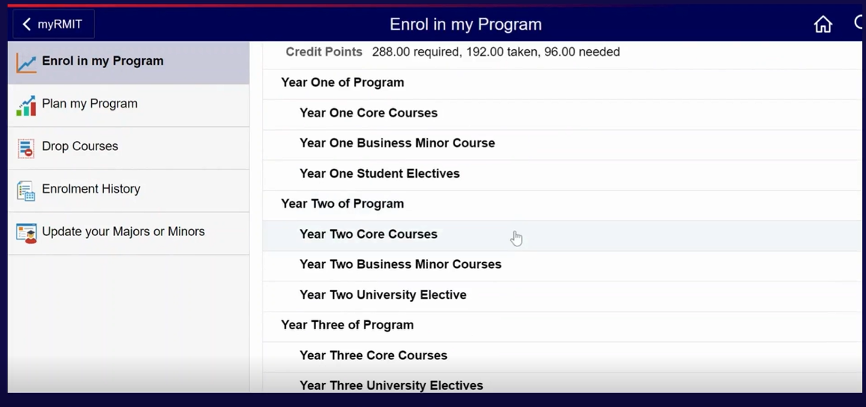
Your Program requirements are displayed in order. All requirements for the year are shown beneath the relevant year heading. This document will show an example of choosing courses for Year 2 of the Program. To follow the example, click the Year Two Core Courses row under Year Two of Program.

Slide 18: Year Two Core Courses
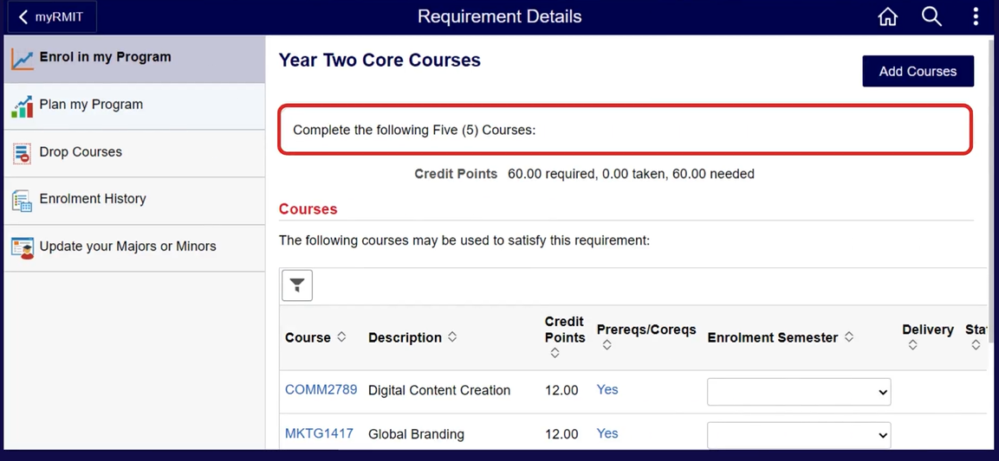
The core courses for the year are displayed in a table with columns Course, Description, Credit Points, Enrolment Semester, Delivery and Status. In this example, 5 courses are listed for Year 2, with the instruction Complete the following Five (5) Courses. This shows that you must enrol in all five courses listed for Year 2 of the Program.

Slide 19: Review the Program Map – Core Courses
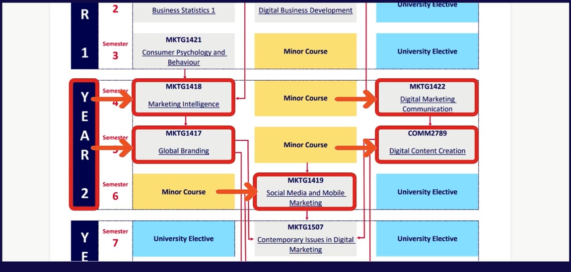
Review the Program map to see which semester you will need to select for enrolment. This will ensure that you complete the courses in the required order.

Slide 20: Year Two Core Courses – Enrolment Semester
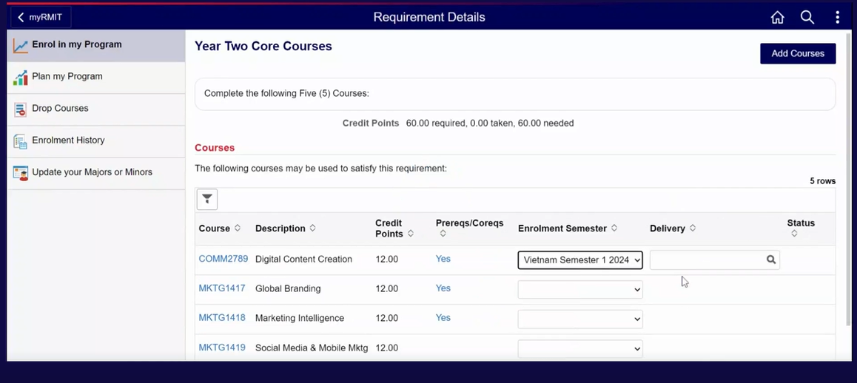
Select the Enrolment Semester from the drop-down list against each course.

Slide 21: Delivery Option
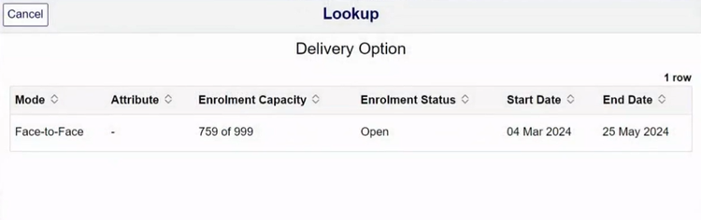
Click the look up icon in the Delivery Option field against the course. This beings up the Delivery Option pop-up. Select the required Delivery Option by clicking anywhere on the row for that option. In this example it is face-to-face.

Slide 22: Add Courses
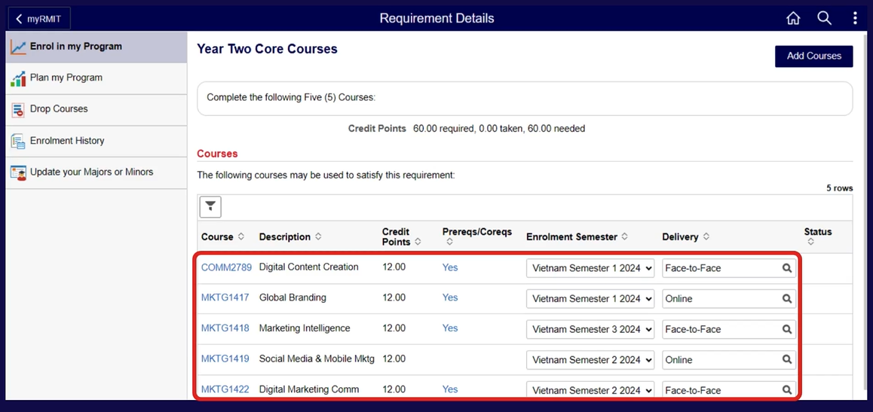
Repeat the same steps for all 5 core courses. Once you have finished selecting your core courses, click the Add Courses button in the top right of the screen.

Slide 23: Add Courses confirmation
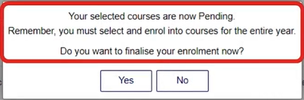
A confirmation pop-up is displayed with the text: Your selected courses are now pending. Remember you must select and enrol into courses for the entire year. Do you want to finalise your enrolment now? Click the Yes button to confirm or the No button to go back and change some details.
In the example, as of now, you have only selected your core courses. You must remember to also select any major, minor and elective courses before finalising your enrolment, so click No. This returns you to the program structure page.

Slide 24: Enrol in my Program – select Year Two Minors
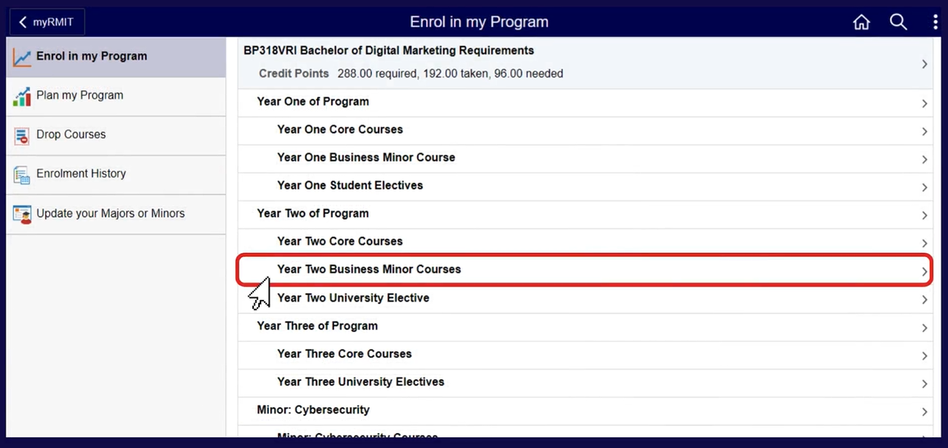
You can now select and enrol in the Minors for year two. Click Year Two Business Minor Courses.

Slide 25: Year Two Business Minor Courses
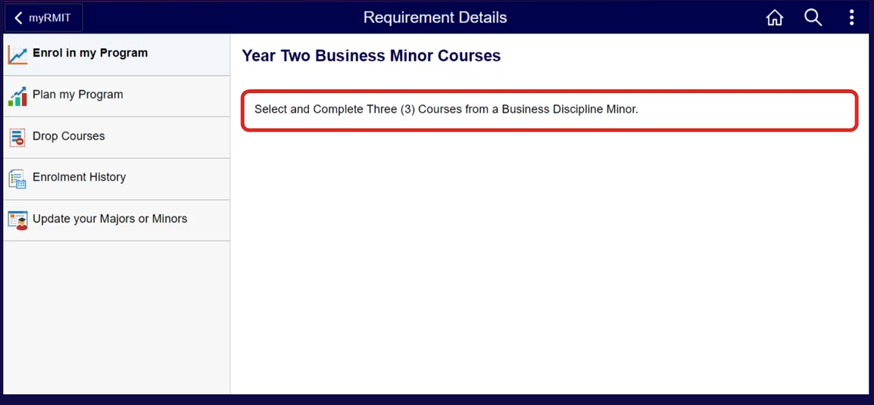
This page tells you how many minor courses you need to enrol in for Year 2. In this example, it is three courses.
Click on the Enrol in my Program tab in the left-hand menu to return to the Program structure.

Slide 26: Select Minor
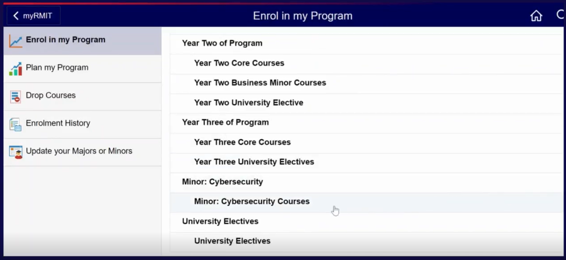
Scroll down the program structure to see your chosen minor. In this example it is Cybersecurity. Click the Minor: Cybersecurity Courses row.

Slide 27: Review the Program Map (Minors)
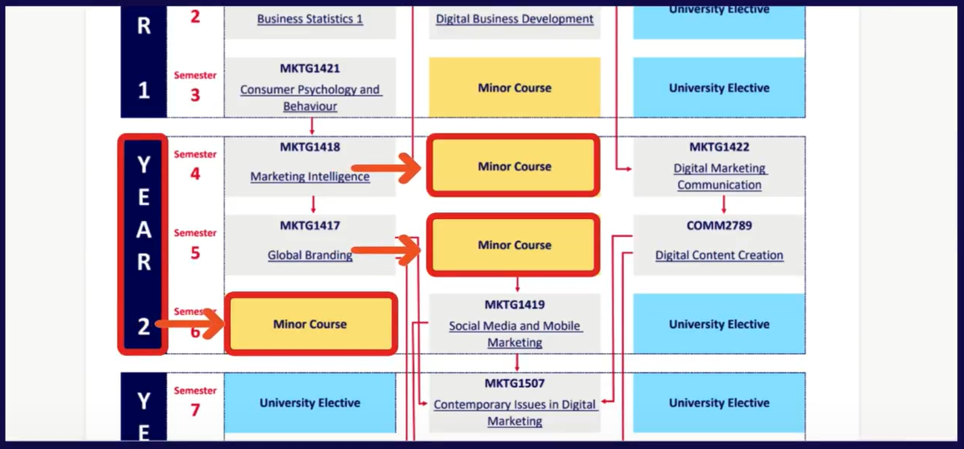
Review your Program Map to see which semester you will need to select for enrolment.

Slide 28: Add Minor Courses
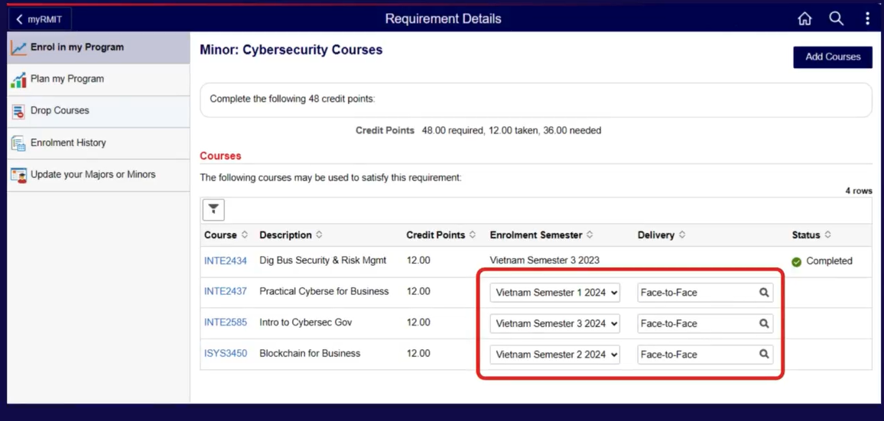
The available courses from the Cybersecurity Minor are displayed in a table with columns Course, Description, Credit Points, Enrolment Semester, Delivery and Status. Select three courses. Select their Enrolment Semesters and Delivery Options in the same way as you did for the Core courses. Click the Add Courses button in the top right of the screen.
You have now selected your core and minor courses. To finish enrolling, you must complete the final item for Year 2, which is selecting your university electives. Therefore, click the No button when the confirmation message Do you want to finalise your enrolment now? is displayed. This returns you to the Program structure page.

Slide 29: Enrol in my Program – select Year Two Elective
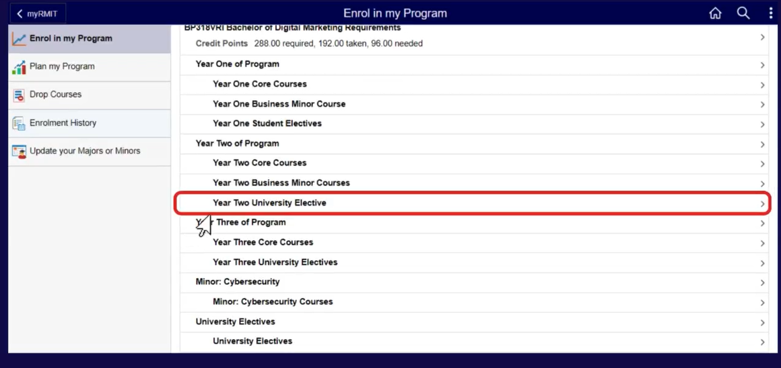
Click on the Year Two University Elective row.

Slide 30: Year Two University Elective
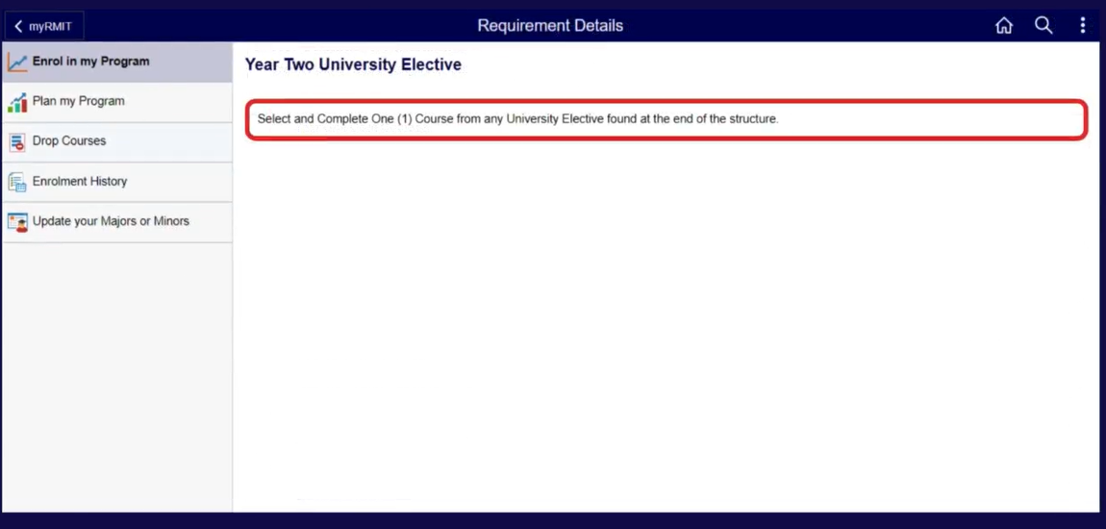
This page tells you how many elective courses you need to enrol in for Year 2. In this example, it is one course.
Click on the Enrol in my Program tab in the left-hand menu to return to the Program structure.

Slide 31: Select Electives
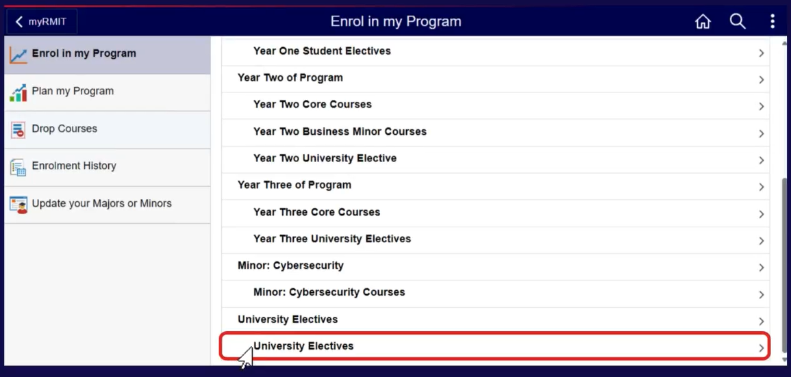
Scroll down to the end of the structure to find available university electives. Click anywhere on the University Electives row.

Slide 32: Review Program Map (Electives)
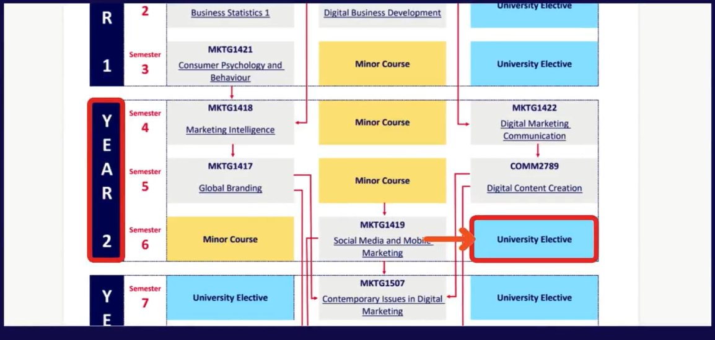
Review your Program map to see which semester you will need to select for enrolment in electives.

Slide 33: Add Electives
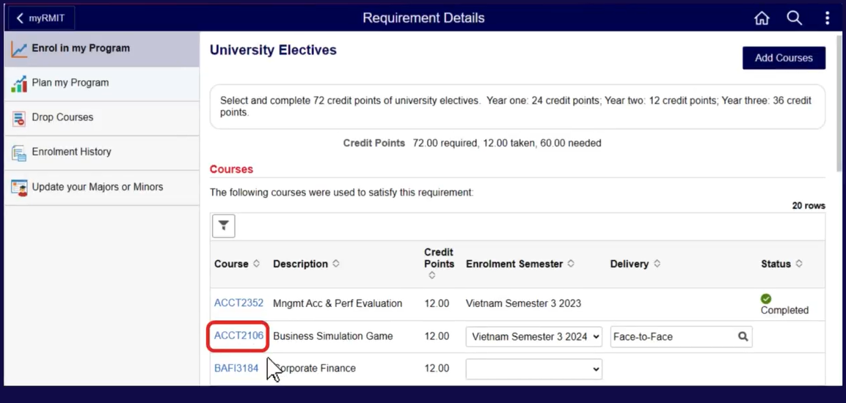
The courses available to be selected as electives are displayed in a table with columns Course, Description, Credit Points, Enrolment Semester, Delivery and Status. To view more details about a course, click the course code hyperlink in the Course column. This brings up a pop-up showing further information.

Slide 34: View Course Detail
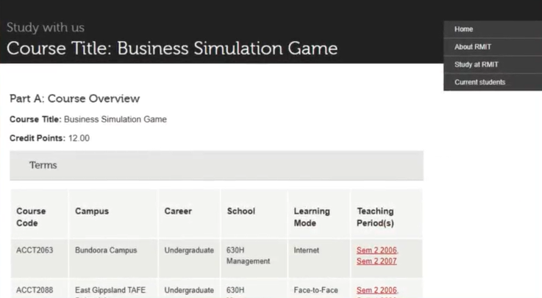
The course detail pop-up shows the Course Title, Credit Points, Course Code, Campus, Career, School, Learning Mode and Teaching Period for the course.

Slide 35: Select Electives
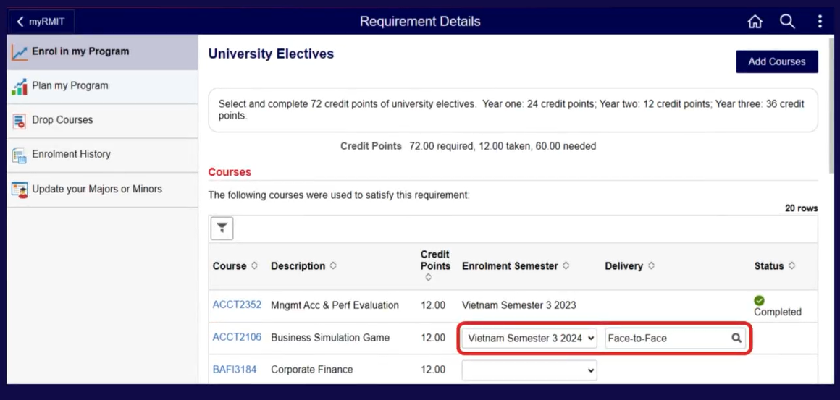
Select one elective course. Select the Enrolment Semester and Delivery Option in the same way as you did for the Core courses. Click the Add Courses button in the top right of the screen.
The finalise enrolment confirmation pop-up is displayed.
You have now completed all items for Year 2 and are ready to finalise your enrolment, so click the Yes button.

Slide 36: Review and Enrol
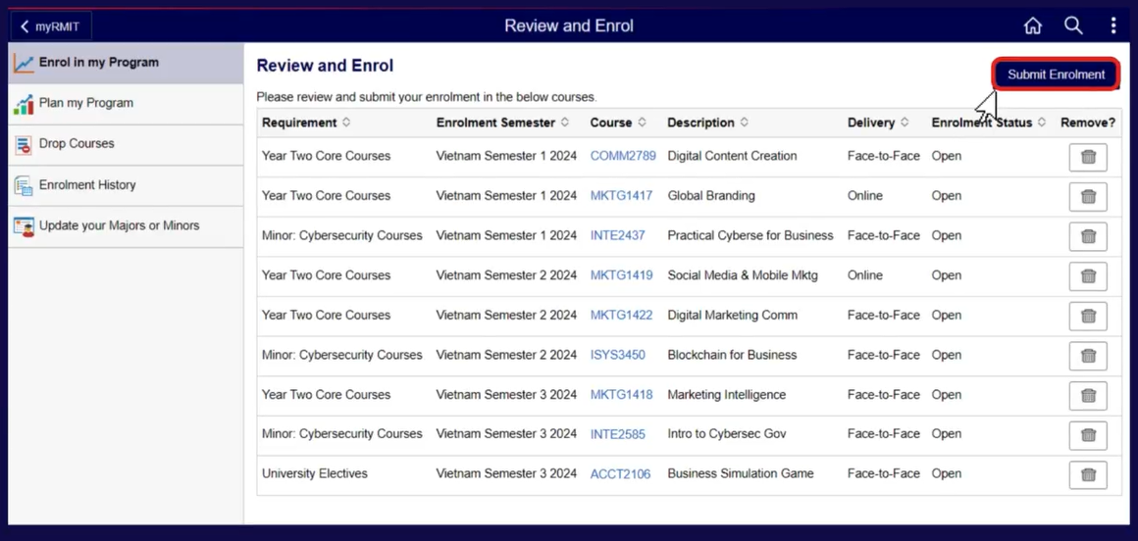
This screen shows all the selected courses in a table with columns Requirement, Enrolment Semester, Course, Description, Delivery, Enrolment Status and Remove.
You can review your enrolments here. If everything is correct, click the Submit Enrolment button in the top right of the screen. A confirmation pop-up is displayed asking Are you sure you want to submit your enrolment? Click the Yes button to submit. This returns you to the program structure screen.

Slide 37: Check Enrolment History
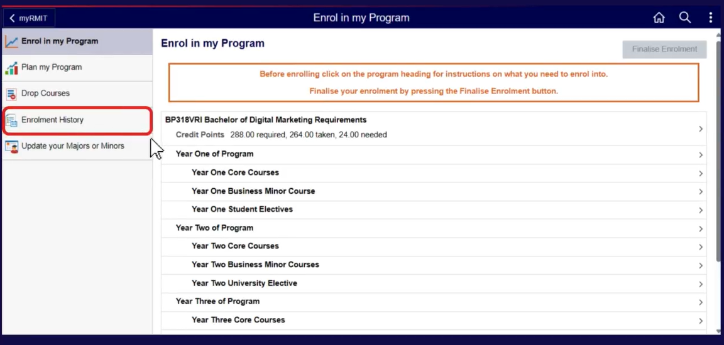
It is important to check the enrolment history page. Form the program structure screen, click the Enrolment History tab on the left-hand menu.

Slide 38: Enrolment History
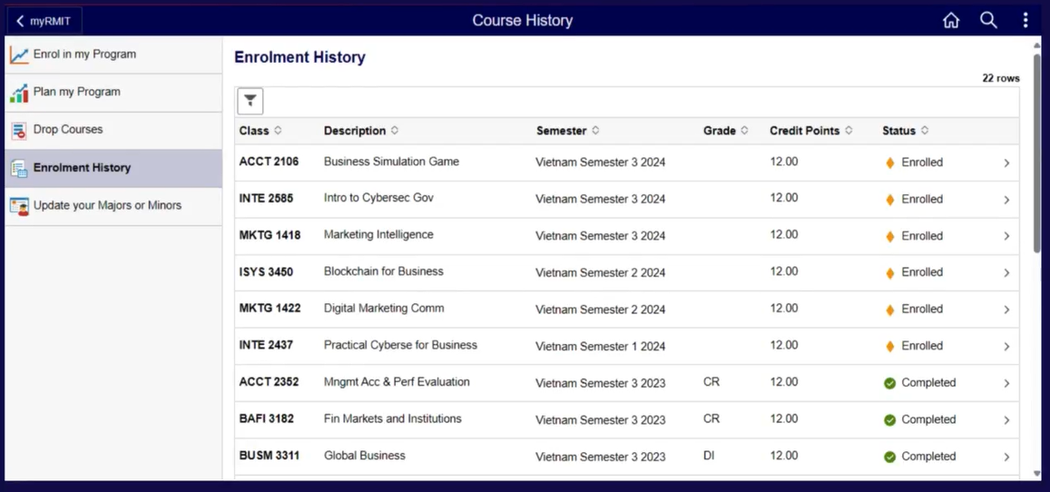
This screen shows all the confirmed enrolments in a table with columns Class, Description, Semester, Grade, Credit Points and Status.
Ensure that all enrolments for the entire academic year appear here.
You have now successfully completed your enrolment.
For more detailed steps, refer to the Quick Reference Guide How to Enrol, linked to this document.

Slide 39: Topic 3 - Update Majors or Minors

Slide 40: Plan my Program
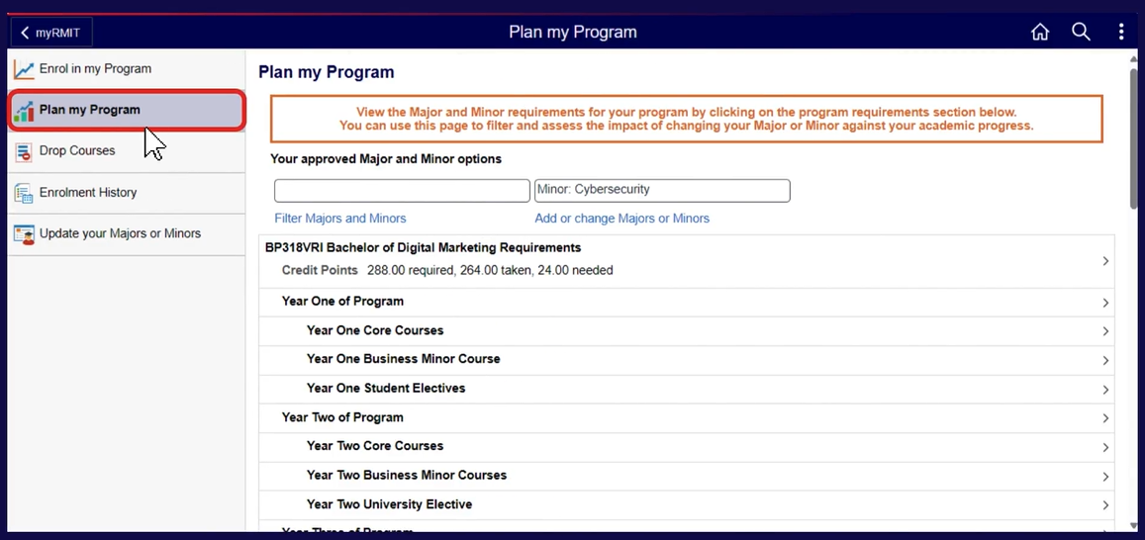
To view all the available majors and minors for your Program, click on the Plan My Program tab in the left-hand menu of the Enrolment landing page, ie. The first page you see after selecting the Enrolment tile. This page can be used to filter and assess the impact of changing your minor or major against your academic progress.
Refer to the Quick Reference Guide Update Major or Minor linked to this document to find out how to update your selected major or minor.

Slide 41: Topic 4 – Drop Courses

Slide 42: Drop Courses
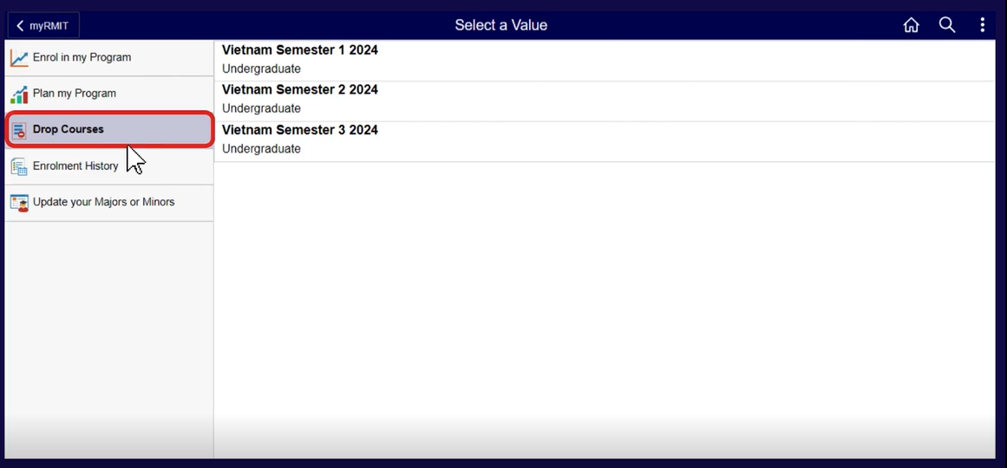
To drop courses that you are enrolled in, click on the Drop Courses tab in the left-hand menu of the Enrolment landing page, ie. The first page you see after selecting the Enrolment tile.
This page shows a list of semesters for which you have course enrolments. Click on the semester for which you wish to drop courses.

Slide 43: Drop Classes – Select a Value
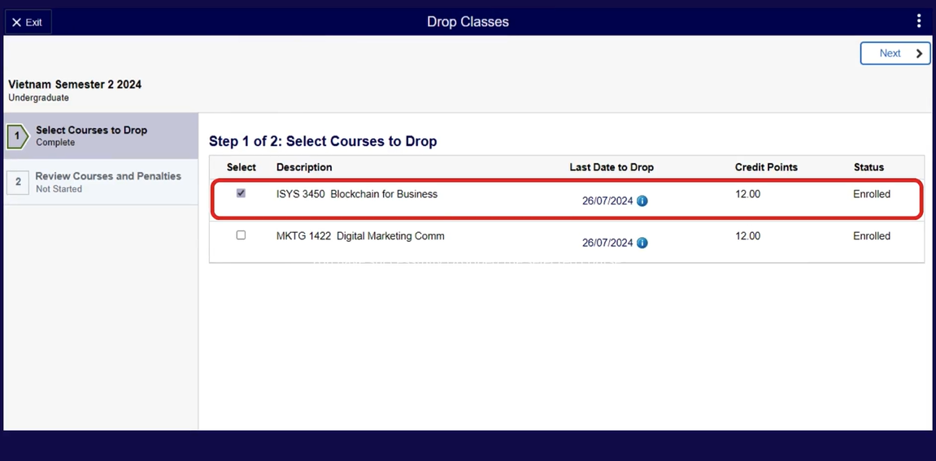
A list of enrolled courses for that semester is displayed in a table with columns Select, Description, Last Date to Drop, Credit Points and Status.
Check the checkbox in the Select column against the courses that you wish to drop. Note that you are not allowed to drop all courses within a semester. Click the Next button in the top right-hand corner of the screen.

Slide 44: Drop Classes – Review Courses and Penalties
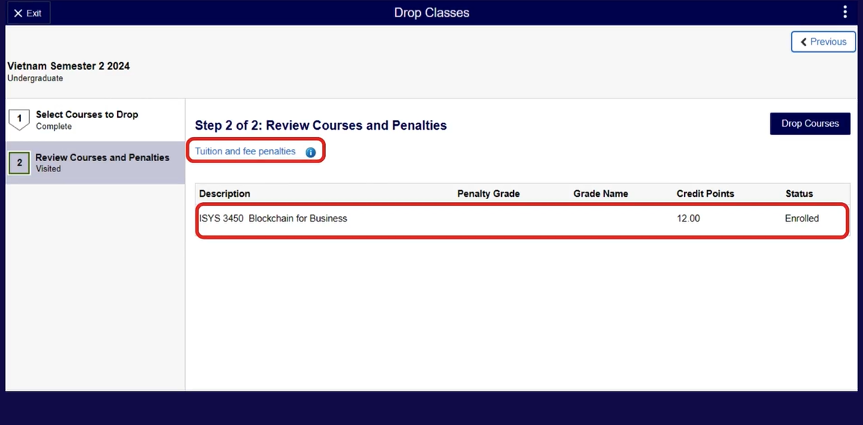
The selected courses are listed in a table with columns Description, Penalty Grade, Grade Name, Credit Points and Status.
For further information regarding fees and penalties, click the Tuition and fee penalties hyperlink above the table.
Review the courses listed and their tuition and fee penalties. To drop all the listed courses, click the Drop Courses button in the top left-hand corner. A message will be displayed confirming the courses that have been dropped.
You have now successfully dropped the selected course. For more details refer to the Quick Reference Guide How to Drop Courses linked to this document.

